Project Design Phase-II
Technology Stack (Architecture & Stack)

Date | 06/02/2026
Team ID | LTVIP2026TMIDS81483
Project Name | Prosperity Prognosticator: Machine Learning for Startup Success Prediction
Maximum Marks | 4 Marks

Technical Architecture:
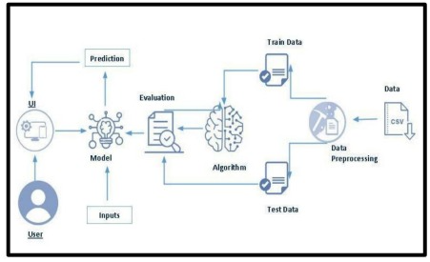

Table-1 : Components & Technologies:

S. No | Component | Description | Technology
 | User Interface | Web interface where users enter startup details and view predictions | HTML, CSS, JavaScript, Bootstrap
 | Application Logic-1 | Backend logic for handling user requests and data validation | Python (Flask Framework)
 | Application Logic-2 | Machine Learning prediction processing | Scikit-learn (Random Forest)
 | Application Logic-3 | Prediction Result Processing & Confidence Score Generation | Python (Flask), Scikit-learn (predict_proba), JSON Handling
 | Database | Stores user details and startup data | MySQL
 | Cloud Database | Cloud-hosted database for production | AWS RDS / Cloud MySQL
 | File Storage | Stores ML model (.pkl) and reports | Local File System / AWS S3
 | External API-1 | Gmail authentication for login | Google OAuth API
 | External API-2 | LinkedIn authentication integration | LinkedIn OAuth API
 | Machine Learning Model | Predicts startup success or failure | Random Forest Classifier
 | Infrastructure (Server / Cloud) | Application deployment environment | Local Server (Development) / AWS EC2 (Production)

Table-2: Application Characteristics:

S. No | Characteristics | Description | Technology
 | Open-Source Frameworks | Frameworks used for development | Flask, Scikit-learn, Bootstrap
 | Security Implementations | User authentication, encrypted passwords, secure API access | SHA-256 Hashing, HTTPS, OAuth 2.0
 | Scalable Architecture | 3-tier architecture allows scaling of frontend, backend, and database independently | AWS EC2, Load Balancer
 | Availability | System hosted on cloud ensuring 24/7 uptime | AWS Cloud Infrastructure
 | Performance | Fast prediction response (<3 seconds), optimized model, minimal latency | Flask API Optimization, Model Caching

